Marks distribution

1. Theoretical-17
2. Cost benefit analysis-17
3. Project scheduling- 16

Chapter 1

Topics in the slide:

* ~~information- A key resource~~
* ~~Major topics~~
* ~~Systems Analysts Recommend, Design, and Maintain Many Types of Systems for Users~~
* ~~A systems analyst may be involved with any or all of these systems at each organization level.~~
* ~~Operational level~~
* ~~Knowledge level~~
* ~~Higher Level~~
* ~~Strategic level~~
* ~~Integrating new tech into traditional systems~~
* ~~Systems analysts need to be aware that integrating technologies affects all types of systems~~
* ~~Ecommerce and Web systems~~
* ~~Enterprise Resource Planning Systems (ERP)~~
* ~~Wireless and Mobile Systems~~
* ~~Open source software~~
* Need for systems analysis and design
* ~~Roles of system analyst~~
* ~~Qualities of the systems analyst~~
* ~~SDLC \*\*\*\*\*~~
* ~~The 7 phrases of the systems development life cycle~~
* ~~Incorporating…..HCI considerations~~
* ~~Identifying problems, opportunities and objectives~~
* ~~Determining human info requirements~~
* ~~Analyzing system needs~~
* ~~Designing the recommended system~~
* Developing and documenting software
* ~~Testing and maintaining system~~
* ~~Implementing and evaluating the system~~
* ~~The impact of maintenance~~
* ~~Approaches to sad and the sdlc~~
* ~~Case tools and classifications~~
* ~~Upper case tools~~
* ~~Lower case tools~~
* ~~The agile approach and agile values~~
* ~~Four agile resources~~
* ~~5 stages of agile development~~
* O-o sad
* ~~Uml phases~~
* ~~Choosing method~~
* ~~When to use sdlc,agile,o-o~~
* ~~summary~~

Mid question 20-21:

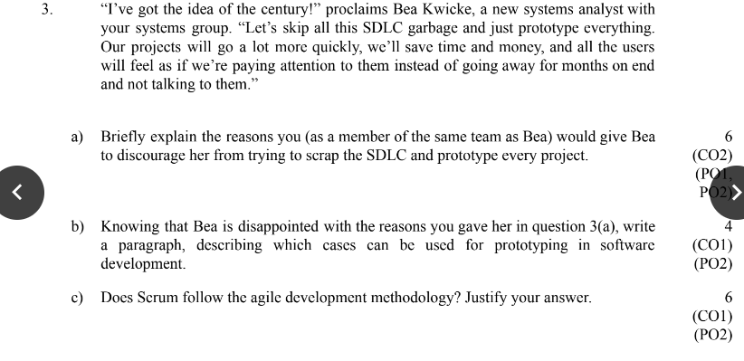

Chapter 3

Topics in the slide:

* Project Management Fundamentals
* Project initiation
* Checking Output, Observing Employee Behavior, and

Listening to Feedback Are all Ways to Help the Analy Pinpoint Systems Problems and Opportunities

* Problem definition
* Problem definition step
* Selection of projects
* Selection of Projects: Improving

Attainment of Organizational Goals

* Defining Objectives
* Determining Feasibility
* The Three Key Elements of Feasibility Include

Technical, Economic, and Operational

Feasibility

* Technical Feasibility
* Economic Feasibility
* Operational Feasibility
* Ascertaining Hardware and

Software Needs

* Steps in Choosing Hardware and

Software

* Inventorying Computer Hardware
* Estimating Workloads
* Evaluating Hardware
* People that Evaluate Hardware
* Acquisition of Computer Equipment
* Purchasing, Leasing, and Renting Advantages and Disadvantages
* Evaluating Vendor Support
* Other Considerations
* Software Alternatives
* Software Evaluation
* Activity Planning and Control
* Identifying and Forecasting

Costs and Benefits

* ~~Identifying Benefits and Costs~~
* Tangible Benefits
* Intangible Benefits
* Tangible Costs
* Intangible Costs
* Comparing Costs and Benefits
* Break-Even Analysis
* Cash-Flow Analysis
* Present Value Analysis
* Guidelines for Analysis
* ~~Estimating Time~~
* ~~Project Scheduling~~
* ~~PERT Diagram Advantages~~
* ~~Project Due Dates~~
* ~~Managing Analysis and Design~~

Activities

* ~~Assembling a Team~~
* ~~Communication Strategies~~
* ~~Project Productivity Goals and~~

Motivation

* ~~Ecommerce Project~~

Management

* ~~Project Charter~~
* ~~Project Failures~~